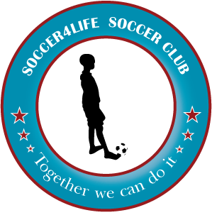


2015 FALL SEASON
LYONS PARK TUESDAYS AND THURSDAYS
5PM - 6PM
CALL 251-786-2062

Registration Fee: $85
Registration Date ___________ Child’s Name:________________________________________
Circle one: Boy Girl School Grade: __________ Age:___ Date of Birth: __/___/__

T-SHIRT SIZE: XS S M L XL SHORTS SIZE: XS S M L XL

Parent’s Name: _______________________________________________________
Address:______________________________________________ City___________
State _____ Zip __________ E-mail* ________________________________
Home #:______________ Cell #:________________ Work #:__________________
Emergency Contact ___________________ Phone#_________________

*Read the following on this page and the second page before accepting:
In consideration of my child being allowed to participate in Soccer4life’s event, I understand that:

“ATHLETIC COMPETITION IN THE REALM OF CHRISTIAN FELLOWSHIP”

Parents’ & Players Must Understand:
1. As representatives of Soccer4life, our words and actions will be reflective of Christian Values. No foul language during soccer practice and games. Please do not bring alcohol or use tobacco.
2. Please use Positive Affirmation toward all children and Coaches. Keep Negative Comments to yourself.
3. Each child, upon signing up for Soccer4life soccer, has agreed to play and abide by all of the program and league rules. Any rule/regulation not complied with will be brought to the attention of the Soccer4life Committee and will be dealt with accordingly. Any child that does not follow instructions may be asked to sit in time out or go home.
4. No insurance is provided by Soccer4life.
5. No refund of money will be allowed due to the advance payment required to order uniforms.
6. Once on the roster, each player must notify Soccer4life coach when unable to attend practice or games. Please have your child at practice on time. Do not drop them off early. Please pick them up on time.
7. I, the undersigned applicant, parent or guardian of applicant for participation in the sports program of Soccer4life, Mobile Alabama do hereby release and discharge Soccer4life and the staff from all liability of any kind and character which might be asserted on behalf of myself or applicant against said released parties. Furthermore, in the event of an accident if the said staff or representatives are unable to contact the parent(s) or guardian(s), we hereby grant permission to said staff or representatives to administer necessary first aid, and/or take applicant to the nearest medical facility for additional treatment.
8. In the event of any injuries that may be caused by my child’s actions or inactions, the actions or inactions of others participating in the activity and the conditions under which the activity is conducted Soccer4life is not liable. I understand the nature of the activity and acknowledge that my child is qualified to participate in such activity.

Multi Media Release
I give permission for my child's picture to be used in publications, advertisements, or video records approved by Soccer4life as related to this recreational activity.

_____________________________ ___/___/____
(Signature of Parent or Guardian) (Date)

